1. Birthday Problem : BdayProblem.java

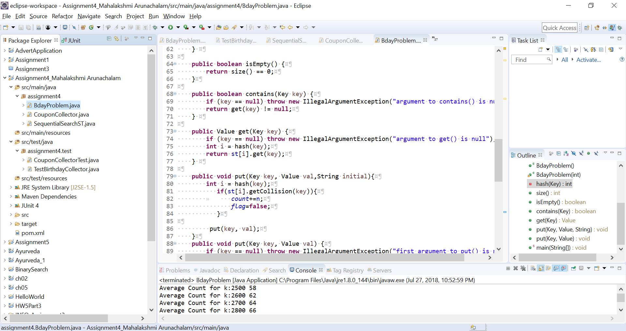

Output:

X axis : Number of Bins/slots

Y axis : number of hashes/throws before the first collision

Values in orange are theoretical values

Values in blue are practical values

The graph show the relation between practical and theoretical values which are approximately equal.

1. Coupon Collector Problem: CouponCollector.java

Output:

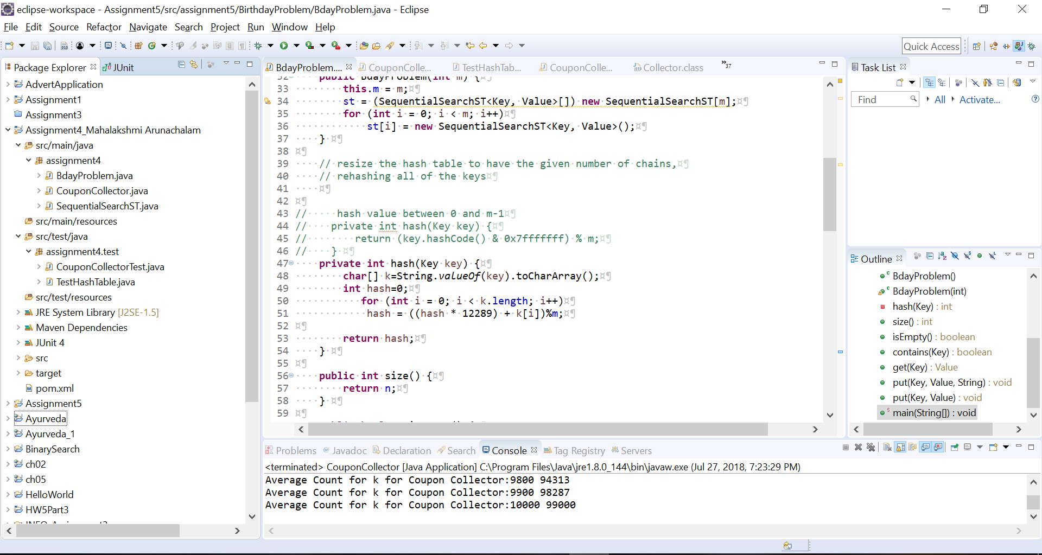

X axis: Number of Bins/slots

Y axis: number of hashes/throws before the first collision

Values in orange are theoretical values

Values in blue are practical values

The graph show the relation between practical and theoretical values which are approximately equal.

Hence practical values were verified against the theoretical values.